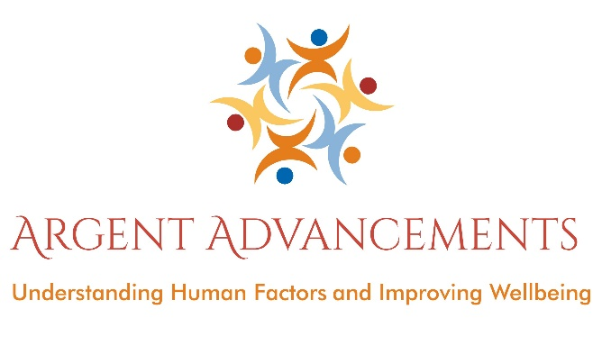
“Our mission is to inspire, educate and empower people so that they may improve their lives, and protect the lives of others.”

Human factors & error management training
In the aviation industry over 80% of incidents and accidents are attributed to Human Error. This is because humans rarely operate at 100% reliability. Our performance is influenced by many things; our physical and mental wellbeing, by organisational decisions, and especially organisational culture. The more performance influencing factors we’re exposed to, the more likely we’ll make errors or break the rules. Errors and violations expose the individual, the organisation and the customer to risk. People break the rules because they feel it’s the only way to get the job done. Many companies do not have a clear picture of the risks they are exposed to because they do not have an appropriate safety culture. The current idea of aviation safety in most organisations is very much reactive – feeling we are safe because nothing has gone wrong in the past. Clearly that’s a perception that’s got to change.
Training in human factors is imperative as it allows individuals and leaders to recognize the times when things might go wrong and put things in place to prevent those bad things from happening. The course encourages staff to say stop in unsafe conditions, and promotes a culture where leaders encourage this behaviour. Such training is appropriate for all staff who have an impact upon safety. That could be anyone within an organisation.
Human Factors training is mandated under EASA / CAA / MAA regulation as it’s recognised that awareness can reduce the risks involved in flying and maintaining aircraft.
The aim of our Human Factors courses is to:
• impart knowledge on human factors and safety
• influence attitudes and behaviour
• Bring about a cultural change to encourage reporting and a just culture so that safety can be managed effectively.
Human factors training isn’t just specific to the aviation industry, in fact, many accidents have their root-cause in human error. These include train, shipping and other transport accidents, incidents within healthcare, manufacturing, and just about any industry where humans are present! As such, this course can be tailored to any industry. Please get in touch if you’d like to know more.
Human factors training should not be something radically new - it covers basic safety principles and practices which should already be incorporated within a safety management and quality system and helps ensure that work is carried out in a professional manner.
However, without effective training, other initiatives related to error management and safety improvement (such as error reporting and investigation, better shift and task handover procedures, improvements in procedure design, etc.) will probably not be effective in the long term. An integrated approach, linking human factors training with organisational safety management and error management initiatives is essential.
Human Factors Training courses
Initial and Refresher courses available. Initial training can be 1 or 2 days. In Aviation - this training is suitable for support staff, hangar, line station and workshop staff, pilots, cabin crew and many others. In fact, it’s best to train the whole organisation as anyone can impact safety.
Topics covered include -
- Why you are here? 80 to 90% of incidents are caused by Human Error.
- History of safety thinking – including latest accident rates and pattern and trend analysis.
- What is Human Factors? The study of people in the workplace environment
- How reliable are we as humans?
- Performance influencing Factors – leads on to…..
- Why humans make errors – includes sections on stress, communication, circadian rhythms and fatigue, shift work, arousal and performance, peer pressure, lack of knowledge, situational awareness, perception, memory, assertiveness, complacency and more.
- Our “Error Defences” – how we defend against error – includes tool control, following procedures, reporting, managing complacency, training, communication etc.
- Error Management –Why we need to report, types of things to report, creating an open reporting culture.
- Blame Cultures and Just Cultures
- How well is your Error Management Systems performing – 3 ages of reporting, discussion on organisational culture and risk.
- Discussion about profit versus safety
- How is safety evolving?
- Discussion at the end about how this course isn’t just a “tick in the box” – Human Factors and Error Management must be at the forefront of their minds as they work
- If the course is aimed at leaders, the focus is very much around leading the safety culture
- If the course is aimed at the general workforce, the focus is very much around contributing to the safety culture.

Felicity from Argent Advancements have been teaching and consulting on Human Factors and Safety Management since 2003 and has worked in aviation for over 20 years. She is highly regarded as a training facilitator and consultant and works with both civil and defence aviation sectors. The workshop is engaging, fun and interactive. It focuses on classroom discussion, with minimal use of powerpoint.
Felicity is a trained Mental Health First Aider and is trained in the management of stress. Workshops in this area are available, although this topic is discussed during a human factors workshop.
Here’s an example of the typical feedback we receive:
“Felicity is currently facilitating 'Safety Culture/Behaviour Workshops with us at Marshall Cambridge and I've observed her deliver in excess of 8 courses. The audience can be 'challenging' at times and I've witnessed her true professionalism and skills at engaging with all participants and delivering quality material. Her open and honest and personable style quickly get her audiences engaged and it's an education to watch her at work in a profession she is obviously passionate about. I can fully endorse Felicity and look forward to seeing her visit Cambridge again over the coming months and years.
Nigel Beedham, Health, Safety and Environment Officer at Marshall Aerospace Defence Group - 12/07/2016
For more feedback please visit www.feefo.com/en-GB/reviews/argent-advancements

Also available is our Safety Management Systems training course.
Awareness courses for general staff and sessions with management to promote understanding of how to create a Just Culture are both available.
Topics covered include -
- Current industry opinions on safety
- What is SMS?
- The Key Components
- The Safety Policy
- Key personnel, required committees and documentation
- Hazard Identification & Risk Assessment
- Just Culture
- Error Management Reporting

www.argentadvancements.com

