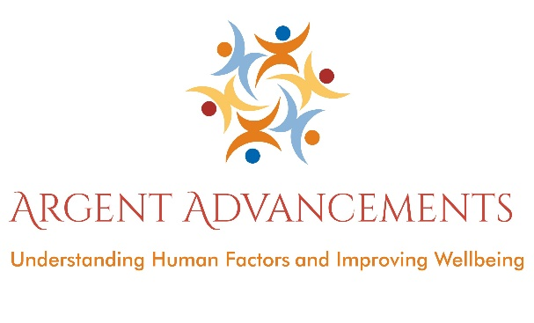
Safety Management Systems (SMS) training course

Safety is more than just the safety manager’s responsibility. Everyone in the organisation has a part to play. Understanding what this looks like and the regulatory imperatives promoting this
Without proper training, other initiatives related to error management and safety improvement (such as error reporting and investigation, better shift and task handover procedures, improvements in procedure design, etc.) will probably not be effective in the long term. An integrated approach, linking human factors training with organisational safety management and error management initiatives, is essential. This SMS course helps you achieve those goals.
The aim of our SMS course is to:
• Provide knowledge about Safety Management Systems in general
- Provide specific details of your own Safety Management system (if relevant)
• Influence people’s attitudes and behaviour
• Encourage open reporting
Areas Covered to include:

- What is SMS and why do we need it
- The Key Components of an SMS
- SMS Documentation and the Safety Manual
- Safety Risk Management
- Hazard Identification, Risk Assessment and Control
- Safety Reporting
- Safety Culture including “Just Culture” and the investigation process
- Continuous Improvement of the SMS
- Summary and any other questions/comments

Argent Advancements also offer a Human Factors and Error Management training package which sits very well with this SMS course.
Initial and Refresher courses available. This training can be provided to Aircraft / component Engineers and support/office staff, Hangar or Line station staff, even pilots and flight crew. Duration is typically 1 day and be carried out at your facility.
Felicity from Argent Advancements have been teaching and consulting on Human Factors and Safety Management since 2003 and has worked in aviation for over 20 years. She is highly regarded as a training facilitator and consultant and works with both civil and defence aviation sectors. The workshop is engaging, fun and interactive. It focuses on classroom discussion, with minimal use of powerpoint. Our courses are designed to promote discussion, both during and after the course with the overall aim of increasing quality, efficiency, and of course safety.
Here’s an example of the typical feedback we receive:
“Felicity is currently facilitating 'Safety Culture/Behaviour Workshops with us at Marshall Cambridge and I've observed her deliver in excess of 8 courses. The audience can be 'challenging' at times and I've witnessed her true professionalism and skills at engaging with all participants and delivering quality material. Her open and honest and personable style quickly get her audiences engaged and it's an education to watch her at work in a profession she is obviously passionate about. I can fully endorse Felicity and look forward to seeing her visit Cambridge again over the coming months and years.
Nigel Beedham, Health, Safety and Environment Officer at Marshall Aerospace Defence Group - 12/07/2016
www.argentadvancements.com

