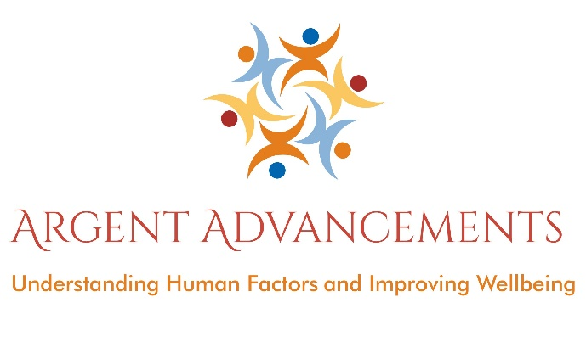

Wellbeing Workshops

Felicity is passionate & inspirational speaker and group facilitator, with 16 years’ experience delivering cultural change programs in organisations. She challenge’s behaviours and mindsets to support and empower your workforce, enabling improvements in individual and organizational safety performance and wellbeing.
Felicity has noticed more and more people are suffering from stress and mental health issues, and as such she takes a keen interest in wellbeing. Felicity is a qualified meditation leader and specialises in other complimentary health techniques to aid relaxation and wellbeing.
Felicity is also a qualified Mental Health First Aider and has trained with the Stress Management Society on their train the trainer programme.
Felicity offers workshops, of various lengths, to help boost staff morale, improve wellbeing, and reduce the costs associated with workplace stress. Sessions for managers are available to help them lead positive change and promote wellbeing within their teams.

A typical workshop would explore the following (length of workshop allowing):

- What is stress; how do we experience stress?
- Is stress always bad?
- The purpose of stress
- Definition of stress
- Causes of stress in ourselves
- Worrying about the past and the future – anxiety and depression
- Strategies for dealing with stress
- Building personal resilience
- Why eating for wellbeing is important?
- Why sleep is important?
- Why exercise is important?
- Relaxation techniques
- Breathing techniques
- Empathetic listening exercise
- Mindfulness meditation
- Desk Massage
- Sessions for managers to help manage the wellbeing of their teams – please see below:
The aim for the managers workshops are to give confidence to your management and team leaders for those situations where their staff’s mental health needs to be discussed and supported. The workshops will provide information to enable the recognition of the signs and symptoms of mental health issues and go on to provide ways for a team leader / manager to create a culture where wellbeing can flourish. Topics covered will include transactional analysis, empathy skills, staff empowerment, embedding a culture to support wellbeing, managing distractions, practical coping strategies and more.

